Homework 4 GPI
- KK 3.3
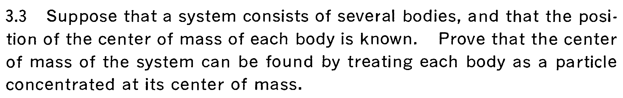
- KK 3.4 （4.4）
- KK 3.5 (4.5)
- KK 3.7 (4.7)
- KK 3.11 (4.12)
- KK 3.14 (4.15)
- KK 3.15 (4.16)
- KK 3.18 (4.24)
- KK 3.19 (4.25)
- KK 3.20
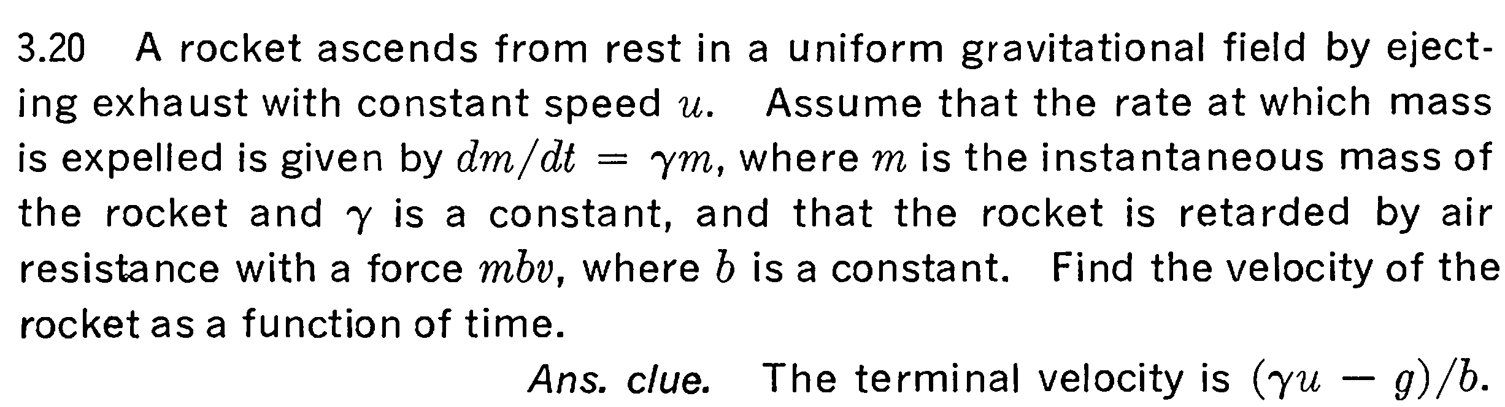
- A rain drop initially with very small size and starts to fall under gravity. As it falls, the vapor will condensate on the droplet and the droplet will increase in size (and mass). Suppose the change of the volume of the droplet (always keeps the spherical shape) is proportional to the volume sweeps by it, i.e. 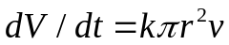, where V is the spherical volume, r the radius and v the velocity of the droplet and k a constant. Please calculate the acceleration of the droplet during this process, if you work out the problem completely you will find the acceleration is surprisingly a constant (g/7), independent of k.
(Hint: it is probably not too hard to write out the relation using impulse theorem. I hope you can complete this at least (both mass and v can change here). The trick of the problem is the spherical shape will also give you a relation on the variation of mass vs. time. The calculation may involve solving differential equations of which the answer can be guessed to take some function form. Of course there are possibly other methods to find the answer)

